**The Cell 2**

**Transport Into and Out of the Cell**

1. **Selectively Permeable**
   * Characteristic of a living membrane.
   * Substances passing through change depending on the cell’s needs.
   * Example: The axon membrane of a nerve cell has gated channels that open or close to allow specific ions to pass only when triggered by a certain stimulus.
2. **Solvent**: The substance that does the dissolving.
3. **Solute**: The substance that dissolves.
4. **Hypertonic**: Having a greater concentration of solute than another solution.
5. **Hypotonic**: Having a lower concentration of solute than another solution.
6. **Isotonic**: Two solutions containing equal concentrations of solute.

**Passive Transport**

* **Definition:** Movement of molecules **down a concentration gradient** (from higher to lower concentration).
* **Energy Requirement:** **Never** requires energy.
* **Types:**
  1. **Diffusion**
     + **Simple diffusion**
     + **Facilitated diffusion**
  2. **Osmosis**

**DR SALMA KHALED BIOLOGY EDUCATOR**

**1. Diffusion**

* **Simple Diffusion**
  + Movement of particles from a **higher concentration** to a **lower concentration**.
  + **Rate:** Faster when the gradient is steeper.
* **Facilitated Diffusion**
  + Relies on **special protein membrane channels** to transport specific substances.
  + Facilitated diffusion does not require ATP/energy.

**2. Osmosis**

* Diffusion of **water** across a membrane.
* Water flows **toward the region with higher solute concentration** (down its water potential gradient).

**Hypertonic Solution**

* Water leaves the cell → cell shrinks (**plasmolysis**).
* Example experiment: Adding 5% sodium chloride to an elodea cell causes shrinkage.

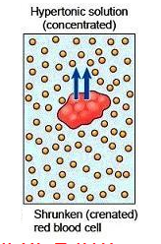

**DR SALMA KHALED BIOLOGY EDUCATOR**

**Hypotonic Solution**

* Water enters the cell.
* **Animal cell:** May burst (lysis).
* **Plant cell:** Swells and becomes **turgid** (cell wall prevents bursting).
* **Turgid pressure** keeps plants firm (e.g., celery, green peppers).
* Loss of water → loss of turgor pressure → wilting.

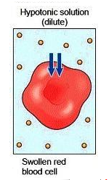

**Isotonic Solution**

* Water moves in and out at equal rates → **no net change** in cell size.
* Used in contact lens solutions and saline eye washes to protect cells.

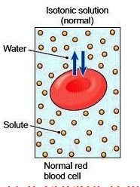

**DR SALMA KHALED BIOLOGY EDUCATOR**

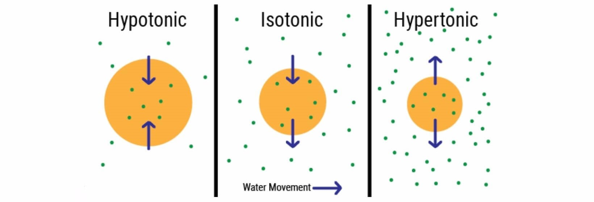

**Active Transport**

* **Definition:** Movement of molecules **against** a concentration gradient (low → high), requiring **energy** (usually ATP).

**Examples of Active Transport**

1. **Contractile Vacuole**
   * Pumps out excess water that enters by osmosis (because the environment is **hypotonic**).
2. **Exocytosis**
   * Active release of molecules from a cell.
3. **Pinocytosis ("Cell Drinking")**
   * Uptake of large, dissolved molecules.
   * Plasma membrane folds inward (invaginates) around the substance and encloses it in a vesicle.

**DR SALMA KHALED BIOLOGY EDUCATOR**

1. **Phagocytosis ("Cell Eating")**
   * Engulfing of large particles or small organisms using **pseudopods**.
   * Forms a vacuole.
   * Examples:
     + White blood cells engulf bacteria.
     + Amoeba feeding.
2. **Receptor-Mediated Endocytosis**
   * Selective uptake of **specific molecules**.
   * Molecules bind to receptors on the membrane → drawn into vesicles.
3. **Sodium–Potassium Pump**
   * Found in nerve cells.
   * Moves Na⁺ out and K⁺ in, against their gradients.
   * Restores the **resting state** after a nerve impulse.

**DR SALMA KHALED BIOLOGY EDUCATOR**

**The Life Functions**

*All cells carry out these essential processes:*

1. **Ingestion** – Intake of nutrients.
2. **Digestion** – Enzymatic breakdown (**hydrolysis**) of food into small molecules that can be absorbed.
3. **Respiration** – Metabolic processes that produce **ATP** for life activities.
4. **Transport** – Distribution of molecules within a cell or between cells.
5. **Regulation** – Maintaining internal stability (**homeostasis**).
6. **Synthesis** – Building large, complex molecules from smaller ones.
7. **Excretion** – Removal of **metabolic wastes**.
8. **Egestion** – Removal of **undigested wastes**.
9. **Reproduction** – Ability to produce offspring.
10. **Irritability** – Ability to respond to stimuli.
11. **Locomotion** – Movement from place to place (**animals only**).
12. **Metabolism** – **Sum total** of all life functions.

**DR SALMA KHALED BIOLOGY EDUCATOR**

**Tools & Techniques to Study Cells**

**1. Compound Light Microscope**

* **Main tool** for cytology (cell study).
* **Magnification** = ocular lens × objective lens.
  + Example: 10× ocular × 40× objective = **400×** total magnification.
* **Resolution** = clarity of the image. High-quality microscopes have high magnification **and** high resolution.
* Image appears **upside-down and backward** compared to the slide.
* Higher magnification → darker field of view.

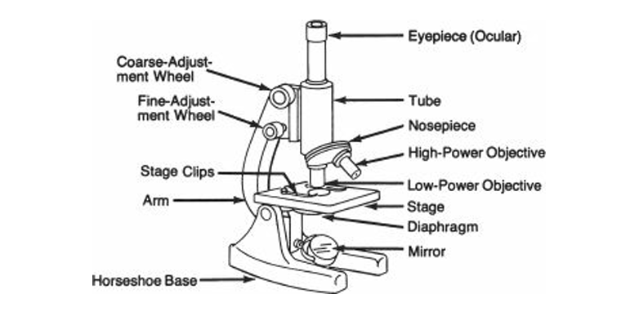



**DR SALMA KHALED BIOLOGY EDUCATOR**

**2. Types of Microscopes**

**Phase-Contrast Microscope**

* Enhances **contrast**.
* Useful for **living, unstained** cells.

**Electron Microscopes**

(Use electrons instead of light — magnification **>100,000×**, superior resolution)

* **Transmission Electron Microscope (TEM)**
  + Views **interior** of cells.
  + **Drawbacks:**
    - Kills tissue.
    - Very elaborate specimen preparation.
    - Extremely expensive.
    - Only small slices of tissue can be studied.
* **Scanning Electron Microscope (SEM)**
  + Views **surface** of cells in **3D**.
  + Kills tissue during preparation.

**Reminder:** All electron microscope (EM) specimens are **not alive**.

**3. Other Cell Study Tools**

**Ultracentrifuge**

* Used for **cell fractionation** (isolating organelles).

**DR SALMA KHALED BIOLOGY EDUCATOR**

**Freeze Fracture / Freeze-Etching**

* For **membrane structure** study using EM.
* Produces a **cast** of the tissue (not the original).

**Tissue Culture**

* Different cells require different growth media.
* Cells can be kept alive for years with care.
* Viewed **unstained** under a **phase-contrast microscope**.

**DR SALMA KHALED BIOLOGY EDUCATOR**